**Analysis of Depression Risk Factors using R**

1. Analysis of Demographic Factors: [Age, marital status, no of children, and education level]

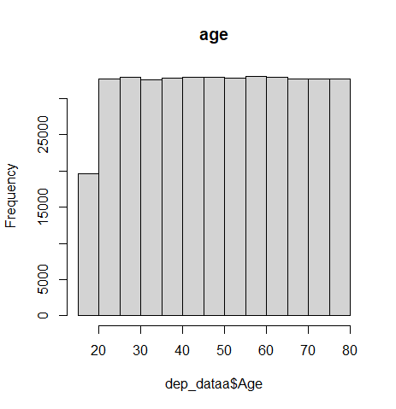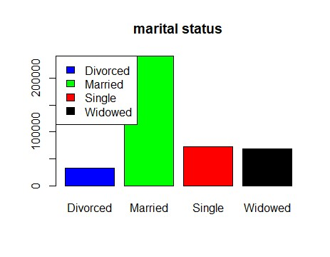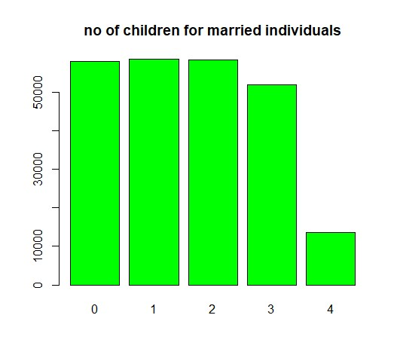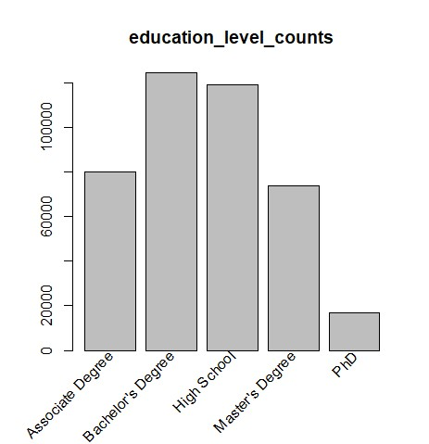

**Insights:**

#We found that depression could happen at any age and it has non-specific age group.

#The majority of depressed individuals are those who are married with number of children less than 4. (the lower number of children the more the individual is susceptible to depression)

#Education level has an impact on depression incidence, as we see from the barplot that the majority of depressed individuals are those holding bachelor’s degree or high school.

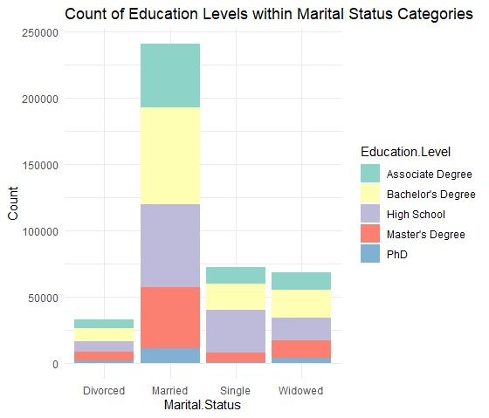

2-Analysis of LifeStyle Factors: [Smoking Status, Physical Activity, Employment Status, Income, Alcohol Consumption, Dietary Habbits, Sleep Patterns] 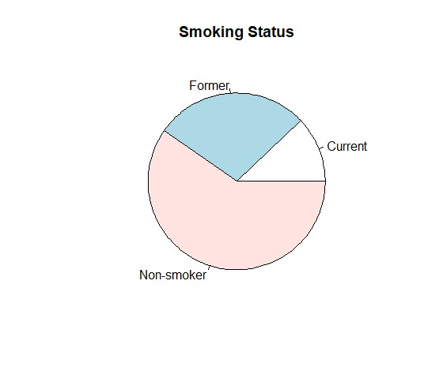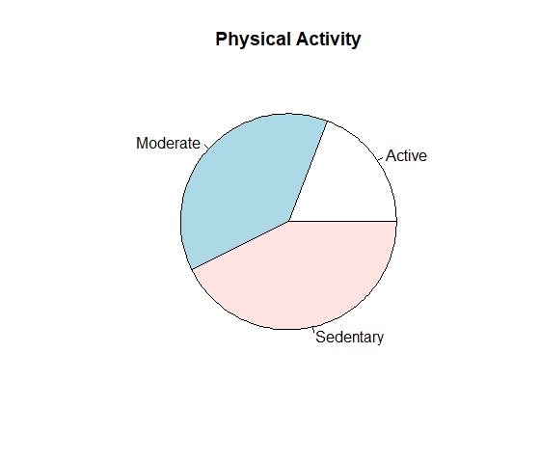

Insights:# From the pie chart we can find that the majority of depressed individuals are non-smoking, which supports the scientific explanation that Nicotine releases dopamine in the mesolimbic reward pathway, elevating mood and improving wellbeing. it also increases the bioavailability of serotonin, acting in a similar manner to some antidepressant drugs. Nicotine has some positive effects, which may be of benefit in depression.

#Also most of depressed individuals are of low or moderate physical activity levels, so Doing Sports can help in preventing depression.

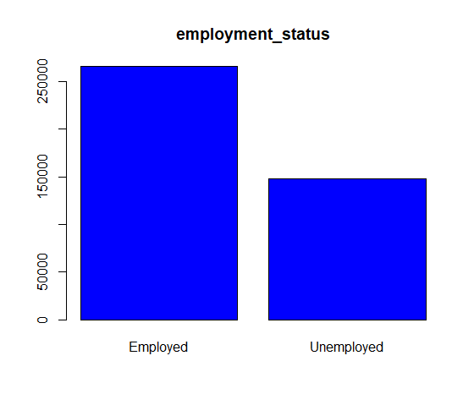

#Also most of depressed individuals are employed which explain that stress of work and work-life imbalance can aggregate depression.

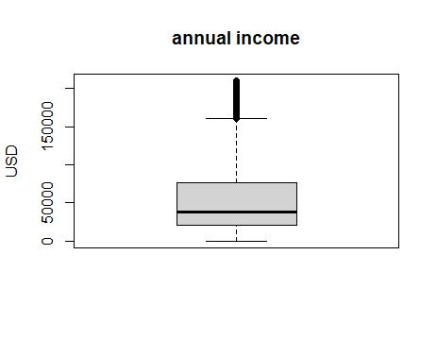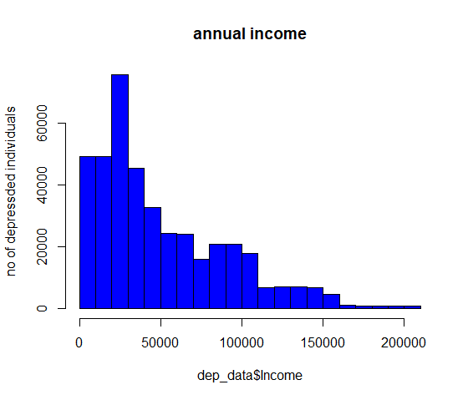

#The majority of depressed individuals are those with low annual income ranges from 0 – 100,000 mostly those with 30,000

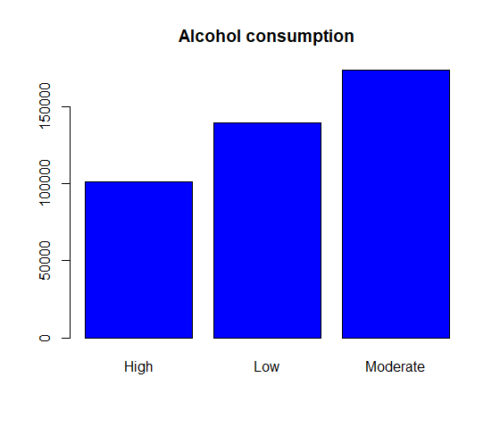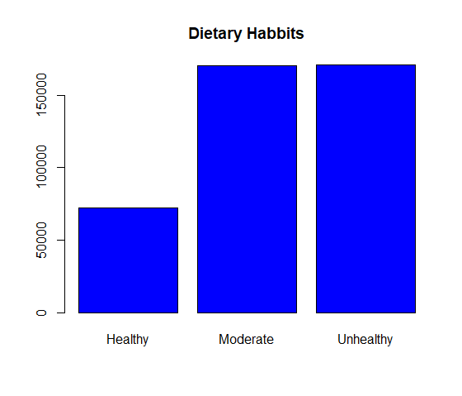

#From the barplot we find that individuals with high alcohol consumption are at low risk of depression and that is because alcohol affects the part of your brain that controls inhibition, so you may feel relaxed, less anxious, and more confident after a drink. BUT these effects quickly wear off. The chemical changes in your brain can soon lead to more negative feelings, such as anger, depression or anxiety regardless of your mood.

#Also eating healthy diets can significantly minimize the depression incidence.

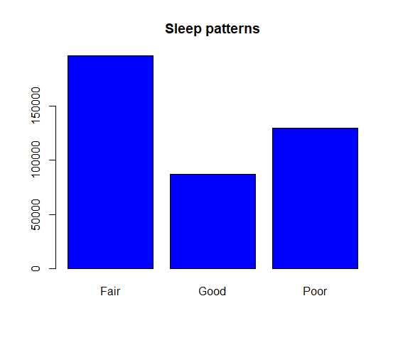

#Having good sleep patterns can also help preventing depression

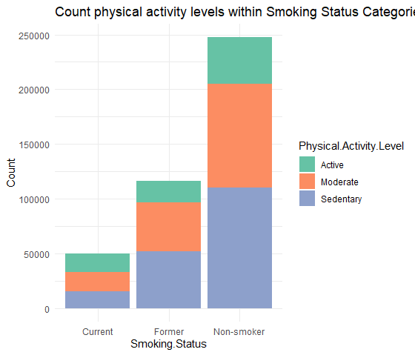

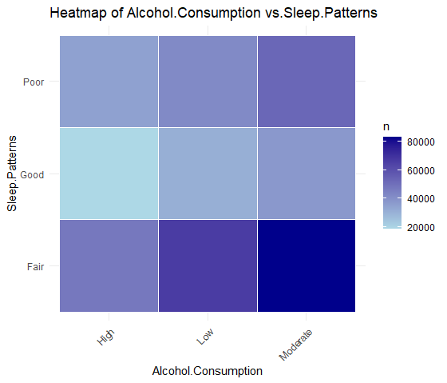

3-Analyzing Medical Condition Factors: [History of mental illness, History of substance abuse, family history of depression, Chronic medical condition]

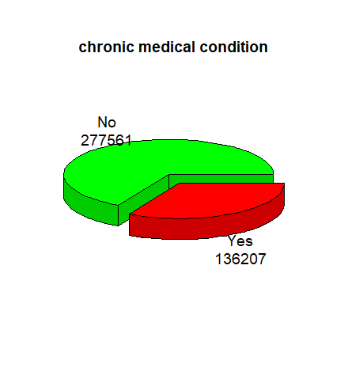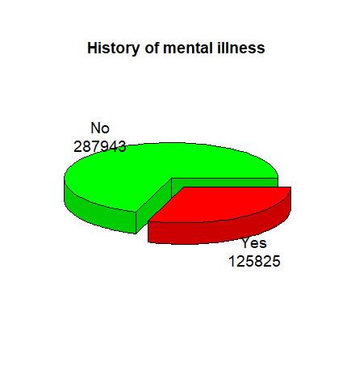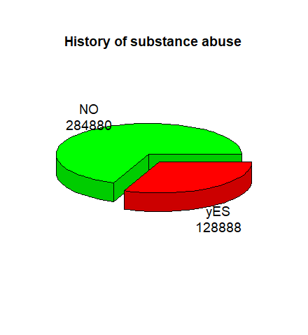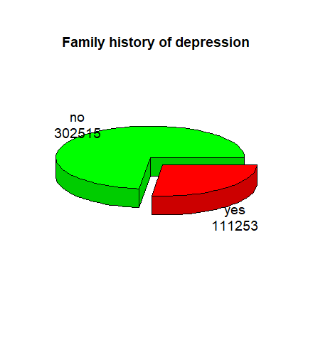

#Contrary to popular belief depression incidence has no relation to either family history ,substance abuse, history of medical illness, or chronic medical condition according to what we concluded from the given data, which needs further investigation.